ØØ Explanation :
- We have an array of 10 numbers for e.g. So we initialize the counter with 10. Also we initialize a pointer to point these numbers.
- Compare first number with initial number. If number < minimum number, save number otherwise increment pointer to compare next number. Decrement counter, compare till all the numbers are compared. Store the maximum number in memory location E000 H.
ØØ Algorithm :
Step I : Initialize pointer.
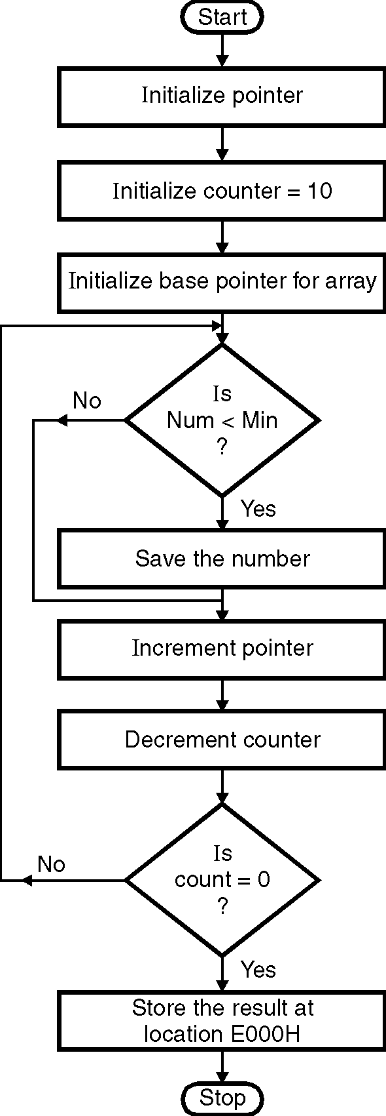
Step II : Initialize counter.
Step III : Initialize minimum =0
Step IV : Compare number with maximum.
If no carry i.e. if number is smaller don’t
interchange then goto step VI
Step V : Save the minimum number.
Step VI : Decrement counter.
Step VII : Increment pointer.
Step VIII : Check if count = 0. If not goto step IV.
Step IX : Store the maximum number.
Step XI : Stop.
ØØ Flowchart : Refer flowchart 33.
ØØ Program :
Instruction Comment
LDA D000H
MOV C, A ; Initialize counter
LXI H, D001H ; Initialize pointer
MOV A, M
INX M
BACK: CMP M ; Is number < miniumum
JC SKIP
MOV A, M ; If number < minimum
; then interchange.
SKIP: INX H
DCR C
JNZ BACK
STA E000H ; Store minimum number
HLT ; Terminate program execution
Flowchart 33

